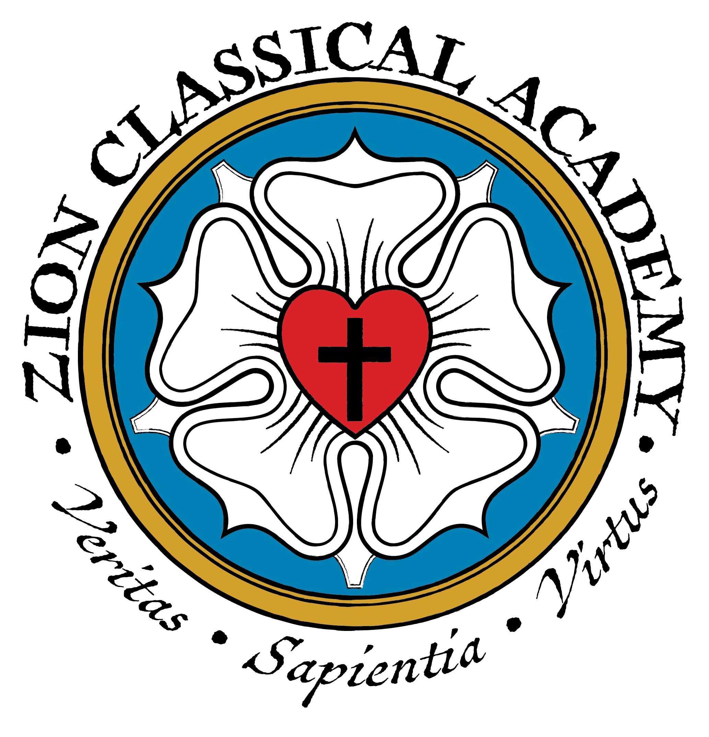

Andy Adams, Principal

New Student Checklist

Congratulations! Your student has completed the application process and has been approved to attend Zion Classical Academy. Below is a checklist for you to follow through the rest of the enrollment process. Please contact us at 402-462-5012 if you have any questions!

Forms that must be completed and returned to the ZCA office:
 Authorization for Release of Information (if student is transferring from a different school)
 Chromebook Contract
 Media Release Parental Consent Form
 Physical Examination Report *
 Student(s) birth certificate*
 Student(s) immunization record*
*These items are kept in each student’s file and are kept in locked storage.

Forms that may be completed and returned to ZCA office:
 Free & Reduced School Meal Family Application (if applicable)
 Medication Authorization (if applicable)

