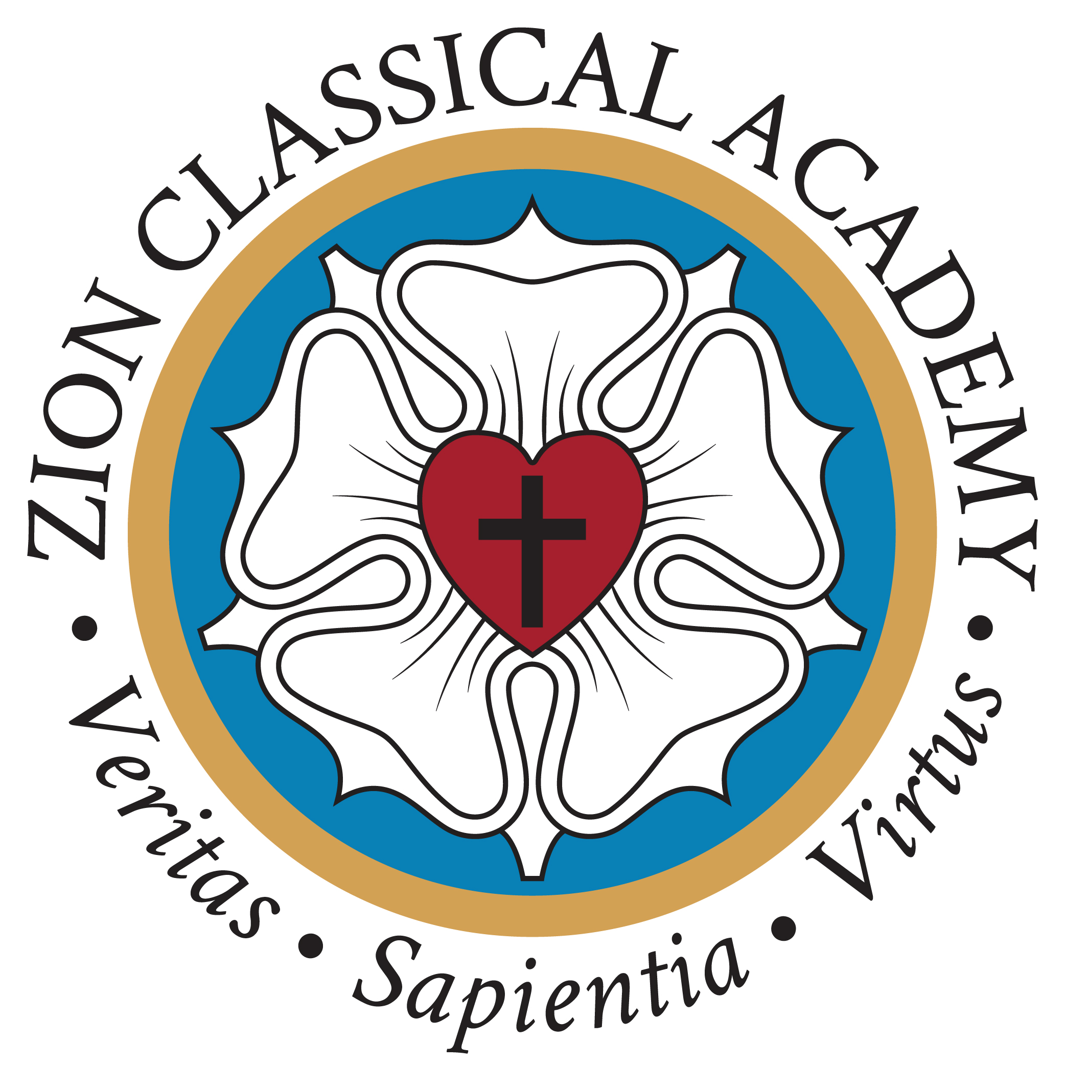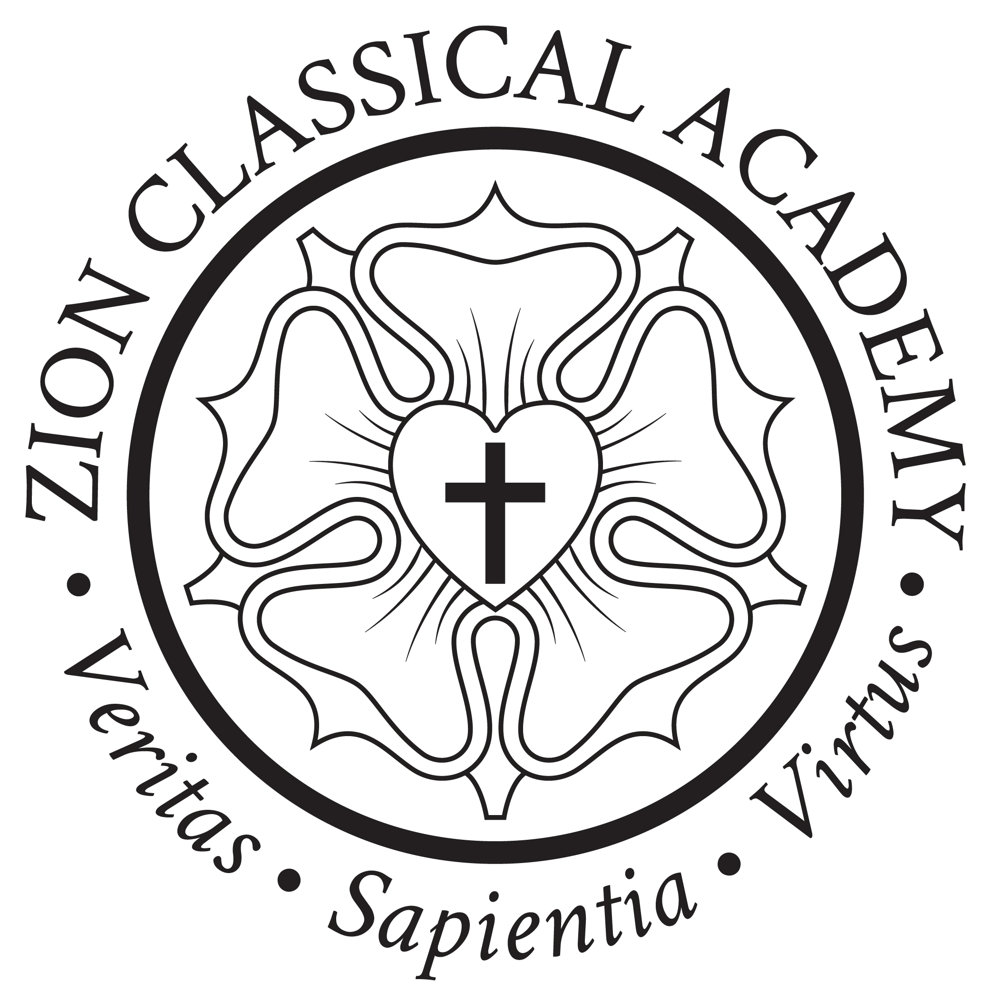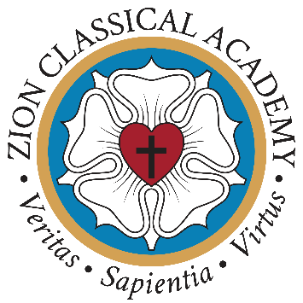

July 12, 2021
Dear Zion Classical Academy Families,
Recently, the Nebraska Department of Education (NDE) released a first draft of Nebraska Health Education Standards – the first of its kind ever proposed. These standards are meant to guide curriculum for all Nebraska schools. These politicized standards include deeply flawed, agenda-driven ideologies that are contrary to the Lutheran Church-Missouri Synod’s vision of the family structure, human sexuality, and marriage. The draft standards teach children that gender is fluid, while also promoting transgenderism and abortion. Age-inappropriate information and ideas about sex, contraception, gender identity, and sexual orientation are taught to students beginning in kindergarten. Read the proposed Health Education Standards for yourself, and take special note of the “Human Growth and Development” section in each grade.
This document does not acknowledge the authority of parents as primary educators of their children – especially regarding sensitive matters such as these. Zion Classical Academy commits to never adopting any such standards or curriculum that contradict our Biblical worldview, statement of faith, or mission statement.
What can you do?

- Pray for Christian teachers and staff serving in our public schools, that they may find opportunities to freely share their faith.
- Double down on your commitment to Christian education for your own family.
- Talk about your concern for the new health education standards with your friends. Make sure that they are aware of the educational standards being proposed for every public school in Nebraska.
- Take advantage of any opportunity that arises to share your concerns with legislators and school board members.
- Watch for local Health Education Standards.

Additional resources regarding the K-12 Health Education Standards:

- Statement from Governor Pete Ricketts
- Nebraska Family Alliance Statement
- Nebraska Catholic Conference Statement
- Protect Nebraska Children Petition
- Nebraska State Board of Education Agendas and Meeting Dates

We at Zion Classical Academy are proud to have the opportunity to partner with parents and serve families to the glory of God. May we stand united in our fight to protect the innocence of our children and defend our precious religious liberties for many generations to come.

In His service,

The Zion Classical Academy Board of Directors

